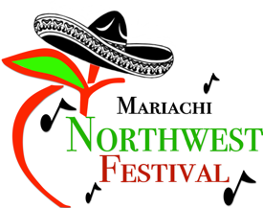
Scholarship Template

Complete applications must be submitted through www.mariachinorthwestfestival.com/scholarship. You may use this form to write your answers, then copy and paste into the online application when ready to submit.

Section 1: Personal Information
Full Legal Name
Social Security Number
Contact Number (include the best number to contact you)
Home Address (include address, city, state, and zip)
Parent/Guardian Name(s)

Section 2: College Plans
What school do you plan to attend?
What is your field of study?
Briefly, state your educational plans:

Section 3: Extra-Curricular Activities
Positions of leadership:
School/community/church activities:

Section 4: Essay Questions
In 300 words or less, please write an essay answering the following questions:
- Describe your goals: personal, educational and career.

- Identify any obstacles (financial hardships, mobility, late entry, early withdrawal, language or cultural barriers) that you have overcome to be a successful student.

- How has Mariachi program impacted your life? And, what would you be willing to do to keep Mariachi alive in our community for the younger generations?

- Needs Statement: Please explain how this scholarship will be beneficial to your educational career.

Section 7: Attachments
Attach Cover Letter
Attach Resume
Attach school transcript (official or unofficial) *
Attach 3 letters or recommendation*
*Please check your school library, office or public library for free access to a scanner

